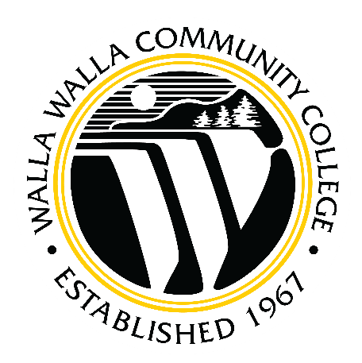

Walla Walla Community College Strategic Enrollment Management Plan

2023-2030

Presented by: The Strategic Enrollment Leadership Council

**Table of Contents**

Introduction 2

Environmental Scan 3

Strategic Enrollment Management (SEM) Defined 3

Strategic Enrollment Management Plan - Purpose 4

College Vision, Mission, and Goals 5

Inaugural SEM Plan Process 7

Key Enrollment Indicators 8

SEM Plan Goals, Strategies, and Tactics 8

Tactics 11

Next Steps 12

Annual Review 12

Definitions/Glossary 13

Strategic Enrollment Leadership Council Members 15

Recruitment Committee Members 15

Onboarding Committee Members 15

Retention and Completion Committee Members 15

References 16

Appendix A 17

Introduction

Regional and external forces (e.g., pandemic, leadership turnover, economic and unemployment factors, lower birthrates, and fewer high school graduates) continue to create challenging enrollment and budgetary conditions for Walla Walla Community College (WWCC) and many other institutions of higher education across the country. In response, WWCC has committed to establishing policies, processes, and procedures dedicated to strategic enrollment management planning and implementation. The intent is to anchor the College in a robust enrollment and retention infrastructure that adapts and responds to the changing higher education landscape in a fiscally sustainable way.

In the summer of 2022, a Strategic Enrollment Leadership Council (SELC) was created with a charge to develop and align the College’s enrollment strategies with the mission, values, and goals of the institution’s [Strategic Plan](https://www.wwcc.edu/strategic-planning/wp-content/uploads/sites/52/2021/01/Strategic-Plan.pdf).  SELC’s primary goal in its inaugural year is to develop a dynamic Strategic Enrollment Management (SEM) plan that utilizes best practices, market research, and institutional data to identify recruitment and retention strategies that adapt to changing environmental factors.

The Council, chaired by the Dean of Enrollment Strategies, is comprised of representative leaders drawn from across the major functional areas of the enrollment pipeline. Other members include executive leadership of Student Services, Institutional Effectiveness, Marketing and Communications, as well as the Director of Budget and Finance, Director of EDI, Assistant Dean of Enrollment Services, and an academic dean. The Council serves the institution in the following capacities:

* Support the vision, mission, and goals of the WWCC Strategic Plan.
* Establish and continuously assess a SEM plan which:
  + sets the direction for optimal recruitment and retention numbers determining a sustainable and vibrant *optimal size* for the College, including supporting the establishment of state and national peer schools for comparison;
  + promotes equitable opportunities in an environment in which all students can succeed at their goals; and
  + supports building infrastructure, processes, and capacity to successfully support students through the entire enrollment pipeline.
* Complement and support the vision, mission, and goals of the WWCC Academic Plan.
* Continuously monitor and analyze data relevant to the Council’s mission and in support of the Academic Master Plan (e.g., inform class scheduling, timing of enrollment activities, and other scheduling efficiencies).
* Conduct annual environmental scanning and forecasting to update the SEM plan and provide actionable data for data-informed decision making across the College.
* Serve as an active member of the larger participatory governance of the College Council

Environmental Scan

Recently, WWCC has undertaken environmental scans both internally and externally recently with the work of strategic planning and mission fulfillment. The most recent summary is included in the College’s [Year Seven Report](https://www.wwcc.edu/wp-content/uploads/2015/01/Year-Seven-Self-Evaluation.pdf) (pp 41-45). Most pertinent to the work of SELC is the [Fall 2021 Enrollment Trends](https://wwcc.sharepoint.com/sites/AccreditationSteeringCommittee/Shared%20Documents/Forms/AllItems.aspx?id=%2Fsites%2FAccreditationSteeringCommittee%2FShared%20Documents%2FYear%207%2C%20Standard%201%2C%20Self%2DEvaluation%2F2022%20Accreditation%20Exhibits%2FEnrollment%20Trends%20Fall%202021%20Conference%20%2Epdf&parent=%2Fsites%2FAccreditationSteeringCommittee%2FShared%20Documents%2FYear%207%2C%20Standard%201%2C%20Self%2DEvaluation%2F2022%20Accreditation%20Exhibits&p=true&ga=1) presentation that captured the effects of the COVID-19 pandemic and other ongoing stressors to the College’s enrollment, demographics, and modes of instruction. This data, along with more recent reports and analysis done by SELC, provides the background for the work of the Council in determining goals and strategies for enrollment and student success.

With the conversion to PeopleSoft ERP, two new Business Systems Analyst (BSA) roles were created to optimize its adoption. Because the entire enrollment pipeline is processed within the ERP, the College’s effective use of the system is highly impactful on enrollment processes. One focus of the BSA’s work is to scan for pinch points and inefficiencies in the College’s use of the system, and then develop solutions for these issues. This continuous scanning for improvement allows for better and more accurate data and processes that then better inform SEM planning and implementation.

Strategic Enrollment Management (SEM) Defined

SEM is a comprehensive coordination of initiatives across the institution to meet College goals. It “enables a college to identify enrollment goals that are aligned with its multiple missions, its strategic plan, its enrollment, and its resources and to reach those goals through the effective integration of administrative processes, student services, curriculum planning, and market analysis” (Kerlin, 2008, p. 11).

The SEM plan and process are designed to achieve and maintain optimum rates within the enrollment pipeline at WWCC, where “optimum is defined in terms of the academic experience and administrative context of the institution” (*Strategic Enrollment*, 2022, p. 3). The plan is divided into complementary elements of Recruitment, Onboarding, and Retention and Completion, with the Strategic Enrollment Leadership Council (SELC) facilitating the alignment of effort college wide.

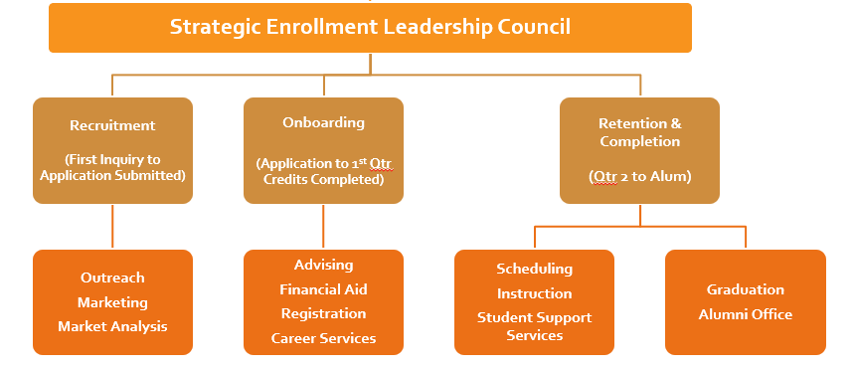

To accomplish these goals, the SEM plan must be intentionally aligned and linked to the College’s Strategic Plan. Further alignment occurs among the Academic, Technology, and Facilities master plans, Mission Fulfilment department plans, Institutional Effectiveness goals, and Resource Allocation. This results in a cohesive and intentional institutional momentum, where all boats are rowing in the same direction toward the same strategic destination.

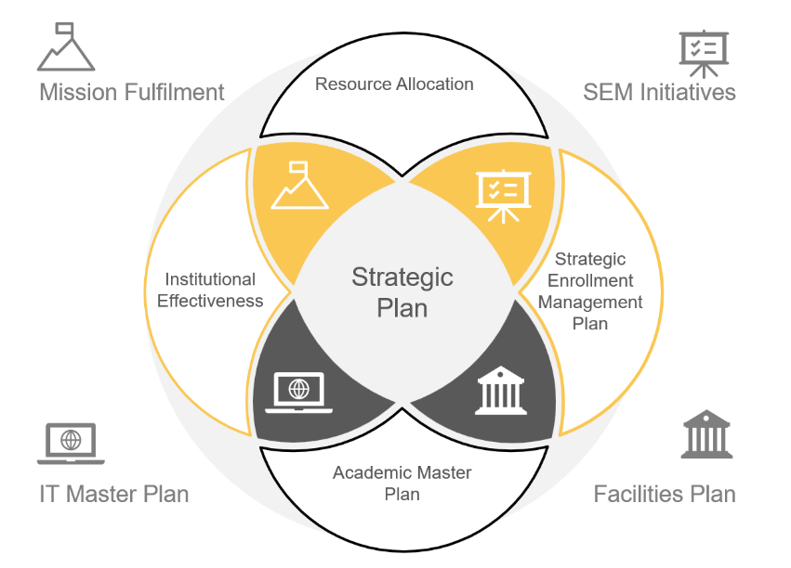

SEM Plan - Purpose

The purpose of an SEM plan is to focus on comprehensive operational strategies to help achieve the mission and goals of the institution. According to Sigler (2017), an SEM plan is built on the following concepts:

* It is concrete and specific.
* It discusses enrollment goals, objectives, assessment criteria, and fiscal and physical capacity.
* It strategically addresses each stage of the student enrollment life cycle from inquiry through alumni.
* It should provide equal attention to student development, retention, and graduation as it does to recruitment.
* It includes an environmental scan and an institutional SWOT (strengths, weaknesses, opportunities, and threats) analysis that is crucial for shaping realistic versus aspirational goals and digging more deeply into factors that drive enrollment.
* It is data-informed using information, metrics, and analytics.
* It draws on best practices.
* It is a multiyear plan to facilitate budgeting and planning, but it remains a living document that will evolve and should be reviewed and updated annually.

WWCC’s Vision, Mission, and Goals

[The 2021-23 Strategic Plan for Walla Walla Community College](https://www.wwcc.edu/strategic-planning/wp-content/uploads/sites/52/2021/01/Strategic-Plan.pdf) describes the College’s Vision, Mission, Goals, and Institutional Values and are included below. The SEM plan is designed to reflect and align with the Strategic Plan to ensure that the SEM initiatives further drive the overall effort in meeting the goals for the College.

Vision

Walla Walla Community College will be the catalyst that transforms our students’ lives and the communities we serve.

Mission

Walla Walla Community College inspires all students to discover their potential and achieve their goals by providing relevant, equitable, and innovative learning opportunities and services.

WWCC Institutional Values: Learning Opportunities, Integrity, Sense of Community, Teamwork, Diversity, Innovation, Health and Humor, Personal and Professional Growth, Excellence, and Sustainability.

Strategic Plan Goal 1

WWCC will provide high-quality pathways for education and training for all students to meet the needs of our communities.

* Objective 1: The College will prioritize equity and accessibility across all instructional modalities and campuses, as well as identify gaps to increase access and improve outcomes for underserved communities.
* Objective 2: The College will increase student recruitment, retention, completion, and transition (assisting students with transition from basic education for adults, transfer for further study, and college-to-career preparedness and placement).
* Objective 3: The College will explore and develop pathways, programs, and training that are relevant to the current and future needs of students and the communities we serve.

Strategic Plan Goal 2

WWCC will be a fiscally sustainable organization.

* Objective 1: The College will continue to develop and prioritize effective outreach, marketing, and recruitment to increase enrollment.
* Objective 2: The College will implement a financial decision-making process that optimizes and prioritizes equitable allocation of resources and creates a transparency in developing and managing budgets, that builds understanding, trust, and that facilitates communications among all stakeholders.
* Objective 3: The College will develop and use resources, both personnel and financial, to support its strategic directions and increase efficiencies while generating additional revenue to meet the needs of the communities we serve.

Strategic Plan Goal 3

WWCC will be welcoming, inclusive, supportive of, and responsive to all communities we serve.

* Objective 1: The College will create an equitable environment where all people associated with WWCC, but especially historically underserved individuals and groups, feel heard, valued, and supported.
* Objective 2: The College will foster trust and inclusiveness in equitable decision making, utilizing participatory governance and transparent communication across all campuses and communities.
* Objective 3: The College will work with community partners (industries, employers, other education providers, and non-profits) to develop and grow pathways and programs to increase educational attainment and to enhance regional economic viability.
* Objective 4: The College will be a respected voice in critical conversations in the communities we serve.

Within the [2021-23 Strategic Plan](https://www.wwcc.edu/strategic-planning/wp-content/uploads/sites/52/2021/01/Strategic-Plan.pdf), the College set three major goals as part of the larger effort toward stabilization in the post-pandemic era. These goals and objectives serve to establish the direction for the development of the SEM plan. Once the strategic plan is complete (to be implemented in Fall 2023), the SELC will review the alignment to the SEM plan and update it where necessary as part of the annual review of the SEM goals and strategies.

Inaugural SEM Plan Process

Following years of challenging circumstances related to enrollment, a global pandemic, and budgetary challenges, the WWCC’s Executive Leadership Team (ELT) determined the need for intentional focus on enrollment planning. To that end, they created the Dean of Enrollment Strategies position and established the Strategic Enrollment Leadership Council (SELC), which the Dean chairs. SELC was charged with establishing the initial SEM plan.

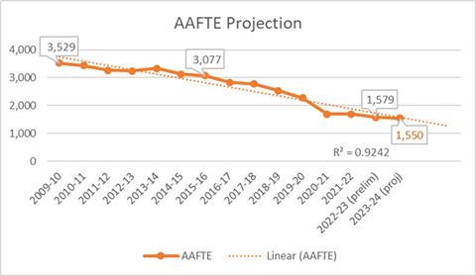SEM planning at this comprehensive, institution-wide scale is new to WWCC and, as such, there are many stages of the process that needed defining. At the same time SEM planning is beginning, the College is undergoing organizational restructuring, Mission Fulfilment implementation, and Strategic Plan development, as well as creating an inaugural Academic master plan. With so many plans in development at the same time, the SEM plan will likely be revised more than once in its first year of implementation. This plan will be considered a working draft until both the College Strategic Plan and Academic Master Plan are completed and alignment is confirmed.

For the inaugural process, SELC prioritized setting the Enrollment Forecast for the College’s budgeting process for 2023-24 planning. Setting the enrollment forecast first allowed the work of the College to move forward, while SELC continued creating the first comprehensive SEM plan (see Appendix A for the complete 2023-24 Enrollment Forecast document).

Next, SELC analyzed enrollment trends and established four broad enrollment goals. Once the goals were identified, the Council’s three subcommittees (Recruiting, Onboarding, and Retention & Completion) met to determine the current and potential future practices aligned with achieving these goals. The practices were further analyzed by SELC and coalesced into ten strategic statements. The tactics for achieving the goals were mapped to identify any gaps. Finally, any tactics with budgetary implications were reviewed by the newly formed Budget Council to determine financial feasibility and prioritization of funding during the annual budget planning process.

Key Enrollment Indicators

Key Enrollment Indicators (KEI) are a set of factors that help the institution understand its complex enrollment patterns in the context of its unique culture and enrollment profile. They are divided into two groups: enrollment cohorts and metrics of success.

Select populations are tracked for enrollment analysis at WWCC. These populations can be analyzed separately or in combination (e.g., male students or male adult learners).

* First time, full time in college
* First time, full time at WWCC
* Student populations by sex (male, female, non-binary/other, unknown)
* 25+ age group (Adult Learners)
* Hispanic
* HUSOC
* Athletes
* Running Start/CiHS
* Incarcerated students
* Students who are parents
* Part time students
* BAS degree-seeking
* Receiving need-based aid

WWCC’s SEM plan metrics for success vary depending on the strategy being measured. Therefore, they are included with each strategic goal in the next section.

SEM Plan Goals, Strategies, and Tactics

A key element of a SEM plan is its alignment to the institution’s strategic plan. Many of WWCC’s goals and objectives served as the blueprint for the SEM goals and strategies described here. The following pages demonstrate the alignment between the College’s current strategic plan and the new SEM plan.

|  |  |
| --- | --- |
| **SEM Plan Goal 1** | 2022-2023: Establish baseline measures, definitions, processes, key enrollment indicators, target populations, and reporting methods for inaugural Strategic Enrollment Management and annual review and revision |
| Strategy A | SELC will collaborate with IR and Data Governance Council to define and establish Key Enrollment Indicators (KEI) and targeted population groups based on nationally recognized practices, as well as SBCTC and CTCLINK data definitions |
| Strategic Plan Alignment | |
| **Goals 1.1, 1.2, 1.3, 2.2** | |

**Measure**(s) of success:

* Completion of Enrollment projection, forecast, and target process for use in setting annual budget and goals. **(Responsible: SELC)**
* Completion of Inaugural SEM plan and annual review process. **(Responsible: SELC)**
* Establishment of College Data Dashboards reflecting quarterly measurement of SEM plan’s KEIs **(Responsible: Institutional Research, SELC, and Business Analysts)**
* ***Know the Numbers*** internal campaign to build SEM awareness. **(Responsible: SELC and Marketing)**
* Build *SSRS* reports for monitoring SEM progress easily. **(Responsible: Institutional Research, SELC, and Business Analysts)**
* Completion of [SELC website](https://www.wwcc.edu/about-wwcc/strategic-enrollment-management-council/). **(Responsible: SELC and Marketing)**
* SEM Quarterly Newsletter. **(Responsible: SELC and SELC sub committees)**

|  |  |
| --- | --- |
| **SEM Plan Goal 2** | 2023-2030: Increase conversion of inquiry-to-enrolled students by 1% annually until 2025 and then maintain that rate through 2030. |
| **Strategy B** | Create marketing and recruitment campaigns for targeted populations. |
| **Strategy C** | Establish and implement scheduled communications and nudges. |
| **Strategy D** | Establish intake and exit surveys to drill into student choices and needs. |
| **Strategy E** | Establish and update educational programming to respond to community interests and economic need. |
| **Strategy F** | Establish and/or improve how students transition from Outreach through Registration. |
| **Strategy G** | Improve and/or build stronger partnership with area secondary schools |
| **Strategy J** | Provide educational delivery options (beyond traditional daytime in person) that are backed by student demand and evidence-based student success data |
| Strategic Plan Alignment | |
| Goal 1.1, 1.2, 1.3, 2.1, 2.2, 2.3, 3.3 | |

Measure(s) of success:

* Tactics are sustainably funded (where needed). **(Responsible: Budget Council/ELT)**
* Enrollment cohorts and metrics are available via dashboard(s) for regular monitoring. **(Responsible: Institutional Research, SELC, and Business Analysts)**
* Instruction and Student Services divisions align and map their departmental workplans to the SEM plan strategies. **(Responsible: Education/Student Services Leadership Councils)**
* Metrics are discussed routinely throughout stakeholder groups and College participatory governance structure. Tactics and departmental workplans are adjusted based on the data gathered. **(Responsible: College leaders at all levels)**
* Educational programming is mapped to demonstrated need and/or demonstrated consumer demand. Changes are implemented based on evidence. **(Responsible: Educational Leadership Council)**
* Secondary school partnerships provide increased opportunities for student access to higher education and professional development for K12 employees. **(Responsible: SELC, Educational Leadership Council, ELT)**

|  |  |
| --- | --- |
| **SEM Plan Goal 3** | 2023-25: Increase enrollment by 2% in targeted population groups.  2025-2030: Maintain our market share of enrollment through the decline in HS population |
| **Strategy B** | Create marketing and recruitment campaigns for targeted populations. |
| **Strategy C** | Establish and implement scheduled communications and nudges. |
| **Strategy D** | Establish intake and exit surveys to drill into student choices and needs. |
| **Strategy E** | Establish and update educational programming to respond to community interests and economic need. |
| **Strategy F** | Establish and/or improve how students transition from Outreach through Registration. |
| **Strategy G** | Improve and/or build stronger partnership with area secondary schools |
| **Strategy J** | Provide educational delivery options (beyond traditional daytime in person) that are backed by student demand and evidence-based student success data |
| Strategic Plan Alignment | |
| Goal 1.1, 1.2, 1.3, 2.1, 2.2, 2.3, 3.3 | |

Measure(s) of success:

* Tactics are sustainably funded (where needed). **(Responsible: Budget Council/ELT)**
* Enrollment cohorts and metrics are available via dashboard(s) for regular monitoring. **(Responsible: Institutional Research, SELC, and Business Analysts)**
* Instruction and Student Services divisions align and map their departmental workplans to the SEM plan strategies. **(Responsible: Education/Student Services Leadership Councils)**
* Metrics are discussed routinely throughout stakeholder groups and College participatory governance structure. Tactics and departmental workplans are adjusted based on the data gathered. **(Responsible: College leaders at all levels)**
* Educational programming is mapped to demonstrated need and/or demonstrated consumer demand. Changes are implemented based on evidence. **(Responsible: Educational Leadership Council)**
* Secondary school partnerships provide increased opportunities for student access to higher education and professional development for K12 employees. **(Responsible: SELC, Educational Leadership Council, ELT)**

|  |  |
| --- | --- |
| **SEM Plan Goal 4** | 2023-2030: Increase student engagement and persistence. |
| **Strategy C** | Establish and implement scheduled communications and nudges. |
| **Strategy H** | Establish workflow for routine identification and communication with stopped out students. |
| **Strategy I** | Foster a sense of belonging and success through activities geared to retain and/or re-engage stopped out students. |
| **Strategy J** | Provide educational delivery options (beyond traditional daytime in person) that are backed by student demand and evidence-based student success data. |
| Strategic Plan Alignment | |
| Goal 1.1, 1.2, 1.3, 2.1, 2.2, 2.3, 3.1 3.3 | |

Measure(s) of success:

* Tactics are sustainably funded (where needed). **(Responsible: Budget Council/ELT)**
* Communication campaigns implemented for stopped out students. **(Responsible: Marketing/Communications, Advising, Outreach)**
* Increase in retention of students in target populations.
* Increase in participation in student activities for target populations. **(Responsible: Student Life, Marketing/Communications)**

Tactics

The goals of the SEM plan serve as the *why*, while the strategy statements serve as the *what,* and the tactical workplans serve as the *how* for achieving those goals. Because tactics are often dynamic and changing in approach in order to respond to real-time data, they are linked here rather than listed. It is SELC’s intention that these tactical workplans are living documents, to be used frequently by committees and frontline departments regularly, and referred to and adjusted as circumstances warrant. ([Tactical Workplan](https://wwcc-my.sharepoint.com/:x:/g/personal/814068337_wwcc_edu/EYyag0dh8TtHqobu-hBUo8MBfVlfaEt4JVFOVbY_hLkfLg?e=8kN2kj))

Next Steps

This inaugural SEM plan provides an overall structure to enrollment management at WWCC. This is a strong first step and allows the College to gather baseline data against which we can measure progress on college enrollment goals. But a plan is not enough in this time of rapid change. To be responsive to changing conditions and encourage innovative ideas, SELC’s continuing work will be to explore the topics and ideas that arise through research, national trends, and the College’s participatory governance structure. This establishes SELC as the body to facilitate the vetting of ideas for their feasibility in becoming initiatives, taking into consideration the College’s capacity and the return on investment of the ideas put forth. The council will set these investigative priorities annually, moving those ideas that are feasible forward through the College Council process toward eventual implementation.

Annual Review

Each August, SELC will review the SEM plan for its alignment to the strategic plan and changing conditions. Goals and strategies will be adjusted, where necessary, to better meet the current conditions of enrollment, retention, and completion. Subcommittees will meet each September to review and adjust tactical plans based on the revised SEM plan culminating with a review of these updates to the College Council, ELT, and Board of Trustees.

Definitions/Glossary

**Adult Learners (also known as non-traditional students):** The National Student Clearinghouse defines non-traditional students as one who satisfies at least one of the following:

* Delays enrollment
* Attends [part-time](https://en.wikipedia.org/wiki/Part-time_learner_in_higher_education) for at least part of the academic year
* Works full-time (35 hours or more per week) while enrolled
* Is considered financially independent for Financial Aid
* Has dependents other than a spouse
* Does not have a high school diploma (completed high school with a GED or other high school completion certificate or did not finish high school)

**Completion:** Eligible students who complete a program. Typically measured in two, three, or four-year cohorts.

**Course persistence:** ([From WWCC STEPS Dashboard](https://www.wwcc.edu/about-wwcc/research-and-planning/steps/)) Refers to a student who persists in the class for the entire quarter without withdrawing, regardless of their final grade.

**Course success:** ([From WWCC STEPS Dashboard](https://www.wwcc.edu/about-wwcc/research-and-planning/steps/)) – Includes students who received a letter grade of C or higher in the course who persisted. See also Course Persistence

**Enrollment forecast:** Anticipated results, informed by assumptions that are deemed most likely to materialize based on analysis and decision-making of the institution.

**Enrollment lifecycle:** The progression of activities and milestones someone undertakes during the course of their time as a student at the college (e.g., Inquiry/recruit, admission, financial aid, enrollment, retention, completion/graduation, alumni)

**Enrollment projection:** Anticipated results based on past performance (assumes all current patterns will remain the same) – also referred to as *the trendline*.

**Enrollment target:** Aspirational enrollment outcomes that require strategic investment and/or institutional focus and capacity to achieve, by which a Strategic Enrollment Plan’s impact can be measured against.

**FTE:** One annual FTE – known as AAFTE (Annualized Average Full-time Equivalent) is the equivalent of one student enrolled for 45 credits in an academic year (summer through spring). One quarterly FTE is the equivalent of a student enrolled in 15 credits in a quarter.

**HUSOC:** Student reported census codes grouped into these categories:

* Historically underserved students of color (Black/Afr. Am, Am Ind/AK Native, Hispanic, Pacific Islander
* White, Asian, Other

**Instructional delivery mode:** Four categories of course delivery: online only, online and face-to-face mixed (hybrid), other distance education, and face-to-face.

**Key enrollment indicators (KEI):** a set of factors that help the institution understand its complex enrollment patterns in the context of its unique culture and enrollment profile.

**Key performance indicators(KPI):** a quantifiable measure used to evaluate the success of an organization in meeting objectives for performance.

**Market share of enrollment:** Thepercentage of total enrollment available for a given location (service area, state, or nationally)

**New student:** SBCTC relies on two definitions for a new student: 1) First-time ever in college; and 2) First-time ever at WWCC from the first quarter they enrolled in an award-seeking program or dual enrollment.

**Optimal enrollment:** Optimal enrollment is achieved when there are sufficient services, delivery modes, and programs to meet the educational, career, and community education needs of the Service Area. Enrollment is managed to ensure current and planned facilities, staff, and resources are available to support demand and maintain quality.

**Peer colleges in system:** [SBCTC defined peer colleges](https://www.sbctc.edu/colleges-staff/research/data-dictionaries) based on size and type (district, mid-sized, rural, technical, and urban/suburban). WWCC’s rural peer group includes: WWCC, Big Bend, Centralia, Gray’s Harbor, Lower Columbia, Peninsula, Skagit Valley, and Wenatchee Valley.

**Peer colleges nationally:** (in development)

**Received need-based aid:** Student who receive need-based aid (financial aid and waivers) OR are enrolled in a low-income program such as WorkFirst or BFET.

**Retention:** The percentage of a school’s first-time, first-year students who continue at the school. Typically measure first to second quarter, and first to second year.

**Stopped out:** Students who do not persist from one quarter to the next.

**Target populations:** Those specific population groups on which the SEM plan is focusing for improvement in enrollment, retention, and/or completion (e.g., Running Start students).

**Traditional students:** Post-secondary students under 25 who enroll directly from high school, attend full-time, and do not have major life or work responsibilities inhibiting their success in higher education.

Strategic Enrollment Leadership Council members

**Chair** - Lisa Chamberlin – Dean of Enrollment Strategies

Graydon Stanley – VP of Student Services

Nick Velluzzi – VP of Enrollment Services and Inst. Effectiveness

Lori Peterson – Director of Financial Reporting and Budget

Karl Easttorp – Director of Marketing and Communications

Christy Doyle – Dean of Access and Opportunity

Tessa Kimball – Asst. Dean of Enrollment Services

Recruitment Committee members

**Chair -** Karl Easttorp - Director of Marketing and Communications

Andrew Wade – Education/Career Navigator

Melissa Rodriguez – Director of Outreach

Sonja Aikens – Development Coordinator

Janet Mallen – Education/Career Navigator

Chris Bigley – Faculty

Danielle Coila – Student Communications Specialist

Onboarding Committee members

**Chair** – Tessa Kimball – Asst. Dean of Enrollment Services

Erika Bockmann – Registrar

Bobbie Hazeltine – FYE Coordinator/Advisor

Kim Hamann – Career Services Specialist

Gwen Dentinger – Education/Career Navigator

Kendra Coffeen – Education/Career Navigator

Marisol Luengas-Maya – Financial Aid Outreach Specialist

Marci Nixon – Program Specialist 2

Retention and Completion Committee members

**Chair** – Christy Doyle– Dean of Access and Opportunity

Magdalena Moulton – Education/Career Navigator

Lisa Stegall – Credentials Evaluator

Matt Stacey – Instructional Support Coordinator

Diana Herrmann – Director of Guided Pathways

Heather Markwalter – Student Affairs Coordinator/Retention Specialist

Brian Gabbard – Faculty

Laura Wooster – Asst Director of Admissions/Registrar

Casey Collins – Faculty

Joshua Slepin– Director of Institutional Research and Effectiveness

References

Choy, S. (2002). Findings from the condition of education: Nontraditional Undergraduates. *U.S. Department of Education, National Center for Education Statistics*, NCES 2002–012, Washington, DC. < <https://nces.ed.gov/pubs2002/2002012.pdf>>

Hossler, D., & Bontrager, B. (2014). *Handbook of strategic enrollment management*. John Wiley & Sons.

Kerlin, C. (2008). A community college roadmap for the enrollment management journey. *College and University*. 83(4):11

Sigler, W. (2017). SEM Core Concepts: Building Blocks for Institutional and Student Success. *American Association of Collegiate Registrars and Admissions Officers (AACRAO)*.

*Strategic Enrollment Management and Retention Plan (2022-2026)*, College of Southern Idaho, Twin Falls, Idaho, 2022.

Appendix A

**2023-24 Strategic Enrollment Leadership Council – Enrollment Forecast**

Definitions:

**Enrollment projection:** Anticipated results, based on past performance (assumes all current patterns remain the same) - also referred to as *the* *trendline*

**Enrollment forecast:** Anticipated results, informed by assumptions that are deemed most likely to materialize based on analysis and decision-making of the institution – also referred to as *the* *Assumptions*

**Enrollment targets:** Aspirational enrollment outcomes that require strategic investment and/or institutional focus and capacity to achieve by which a Strategic Enrollment Plan’s impact can be measured against.

----------------------------------------------------------------------------------------------------------------------------------

**2023-24 Enrollment Trendline Projection prepared by Institutional Research**

Projection of 1550 for FY23-24 State Funded FTE



**2023-24 Assumptions that may impact Enrollment Forecast**

Student Support Initiatives

* CCAMPIS Child Care grant (+)
* Career Services expansion (+)
* FAFSA Outreach positions (+)
* Warrior Pledge (+)

**Student Support Note:** These student supportive initiatives are soon-to-be or have just been implemented. As such, we lack data to estimate their impact.

Instructional Program Initiatives

* CDL reboot (+)
* Phlebotomy reboot (+)
* Medical Assisting reboot (+)
* CNA Reboot (+)
* Garrison Night School reboot (GNS) (+)
* “New Students” have returned (+)
* Industrial Maintenance Stackables (+)

**Instructional Program Note:** Many of the newly-rebooted programs mostly complete in one or two-quarters and range in credits from 12-15 credits with 15-20 students per class anticipated. Since reboots are just beginning, no real enrollment data is available yet.

Relationship-building Initiatives

* Increasing Outreach (+)
* Increasing CRM/Marketing (+)
* High School Partners Conference (+)
* Try a Trade Reboot (+)

**Relationship-building Note:** Relationship-building efforts are maturing but standards to measure of their effectiveness are still being established (especially in Outreach, CRM, and Marketing). It is difficult to quantify how many FTEs we generate from this work at this time, but we know this effort lays the groundwork for getting students in the door.

Potential Negative Impacts

* Continued Economic/Pandemic uncertainty, unemployment levels, and upside-down recession-to-enrollment trend (-/+)
* ASU dual enrollment encroachment on CiHS and RS (-)
* American Dream Academy grant ended (-)
* Fire Science discontinued (-)
* Reduction in Nursing spots due to clinical limitations (-)
* Reduction in CDL from 15 to 12 credits (-)

**Potential Negative Impacts Note:** The only thing certain in our current climate is uncertainty remains. The pandemic has broken all norms of traditional expectation for increased enrollment during economic downturns and [student disengagement with higher ed](https://evolllution.com/attracting-students/retention/student-disengagement-in-higher-education/) remains stubbornly persistent nationally.

**Enrollment Forecast for 2023-24**

The Strategic Enrollment Leadership Council (SELC) believes that the Initiatives being implemented for 2023-24 will positively impact enrollment. However, the following points suggest caution: the instructional programs being added at this time are small and short-term, the student retention and relationship-building efforts are new and lack data and measures, the looming “high school enrollment cliff” continues its decline, and pandemic-driven uncertainty continues. **Therefore, as a Council, we support the Enrollment Projection of 1550 as a conservative budgetary planning number**.

**We recommend establishing the Enrollment Projection Trendline as the budgeting number yearly, as it is conservative and built off longer range enrollment evidence, and it is readily available for each year’s planning purpose.** As enrollment improves, so will the trendline, but it remains a more conservative number, less impacted by short-term events which can help protect the college from budget projection shortfalls and the resulting instability that creates.

**Enrollment Targets for 2023-24**

Based on the initiatives laid out above, SELC recommends setting an aspirational enrollment target (**not to be used for budgeting purposes**) of increasing overall STATE FUNDED enrollment by 2% for the 2023-24 academic year.

It is important for the College to reflect on what that means in terms of NEW students needing to be brought to WWCC:

Projected final state enrollment for 2022-23: 1579 FTE

2% increase equals = 1611 FTE **(32 new FTE)**

* Head count of new students if each took **5** credits: **96** *more* than 2022-23
* Head count of new students if each took **10** credits: **48** *more* than 2022-23
* Headcount of new students if each took **15** credits: **32** *more* than 2022-23

Further, the number of 32 FTE assumes we remain consistent in our retention numbers.

SELC encourages a “Know the Numbers” internal campaign to keep these targets at the forefront of the College’s daily work.

**A Final Note:** As the SEM plan is finalized and adopted, tactics are implemented and measured, and as we get further down the road from pandemic instability, SELC will be able to build confidence in a forecasting model that takes into consideration campus-wide efforts across areas like Marketing, Outreach, Advising, Educational Programming, and Student Financials.